**SQL - Final Project – Question 9 Solutions**

9a. Create the appropriate foreign key constraints.

**Ans:** Implemented in the respective Create statements.

b. Create an entity relationship (ER) diagram for the tables in the database.

**Ans:** Below diagram generated from MySQL Workbench

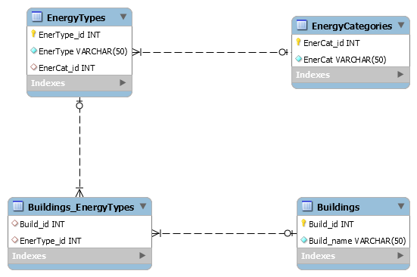

c. Suppose you wanted to design a set of HTML pages to manage (add, edit, and delete) the information in the various database tables; create a mockup of the user interface (on paper or using a package like Balsamiq Mockups).

**Ans:** Attached here as well as github link provided.



d. Suppose you want to track changes over time in energy type preferences in New York City buildings. What information should you add to each table? What might a report that shows the trends over time look like?

**Ans:** There are multiple ways of doing this. It depends on whether we need to store detailed information.

One option is to store the preferences of the building every year. So in this table we will have Year, Build_id and EnerType_id. We can then use this table to generate summary statistics for the Year and EnerType. We can then use the Year and EnerType frequency to generate a trend line for the various years.

The other option is to store the year and summary statistic as a table by itself. So in this table, we will have Year, EnergyType, Frequency as columns. Again as in the above option, we can use this table to generate a trend.